**locate command:**

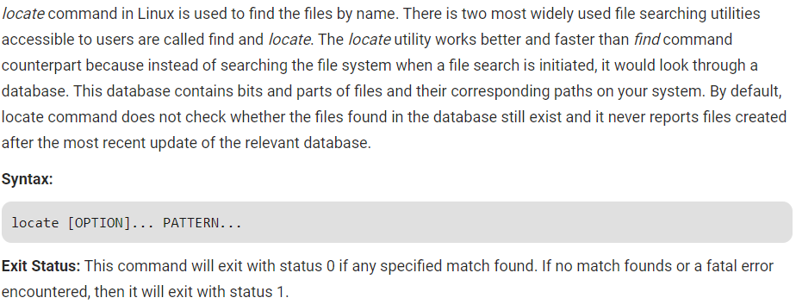

**Options:**

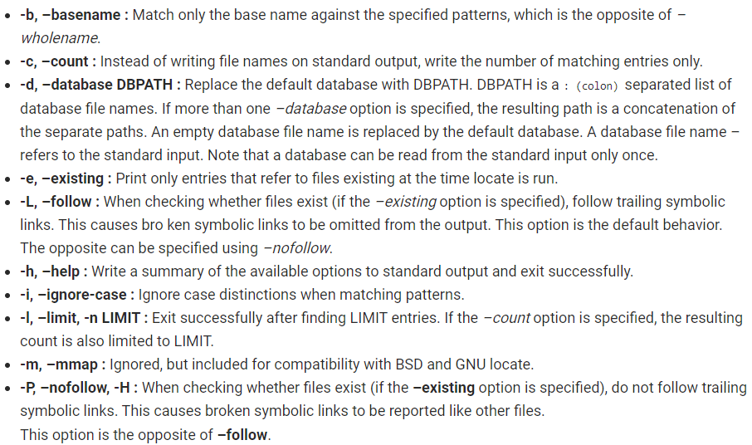

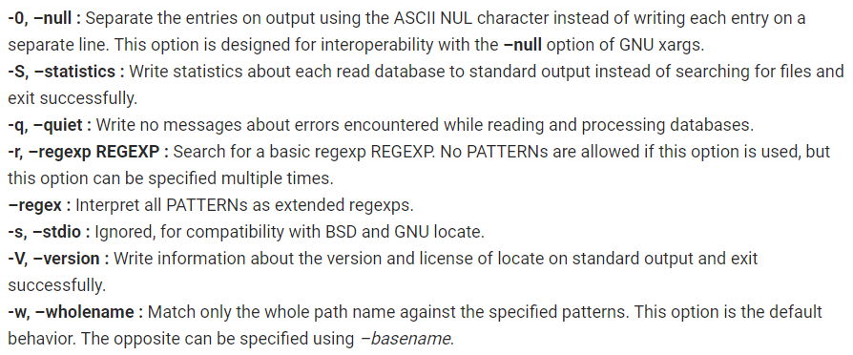

**Examples:**

Search a file with specific name. It will search for sample.txt in particular directory.

* **locate sample.txt**

Limit Search Queries to a Specific Number. It will show **20** results for the searching of file ending with .html.

* **locate "*.html" -n 20**

Display the Number of Matching Entries. It will count files ending with **.txt**.

* **locate -c [.txt]\***

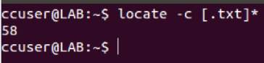

Ignore **Case Sensitive** Locate Outputs. This command is configured to process queries in a case sensitive manner. It means SAMPLE.TXT will show a different result than sample.txt.

* **locate -i *SAMPLE.txt\***

Separate Output Entries Without New Line. Default separator for locate command is the newline (\\n) character. But if someone want to use a different separator like the ASCII NUL, the he/she can do so using the **-0-command** line option.

* **locate -i -0 *sample.txt\***

